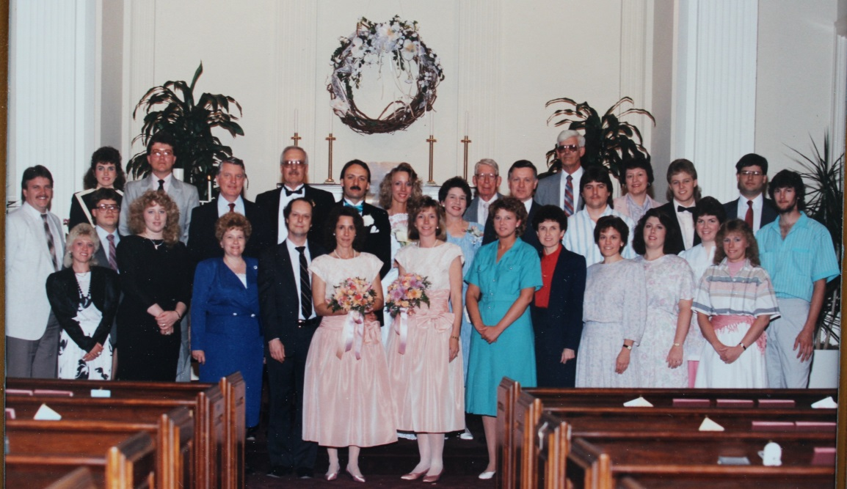

(l-r) Back Row: David Link, Nan List, Brent List between rows, David John List in gray suit, David List, Ron List, Mark Sweeney, Judie List Sweeney (bride), Jo Ann Clark List, Gordon Worthen, Mark List, Don Raasch, Dottie Jo List Raasch, Roger List, Doug Raasch, Dan Raasch

Front Row: Ann List Link, Malena List, Carolyn List, Greg Markel, Susan List Markel, Marilyn List Williams, Dawn List Ream, Jeanette Chapman List, Brenda List Huffines, Debbie Raasch, Mary Jo Raasch, Jackie Snyder Raasch - 13 May 1989

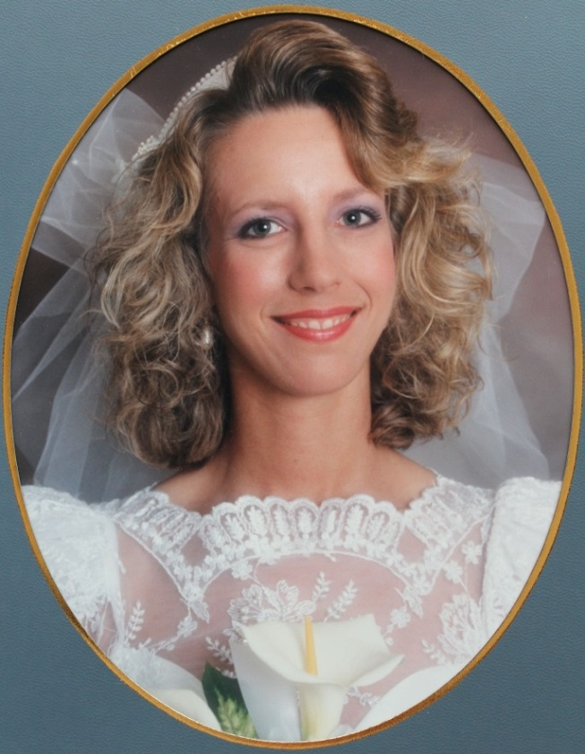

Judith (Judie) Ann List - 13 May 1989